Room 3 Question 1
Gallstone Ileus
Stem: A 76-year-old demented woman presents to the emergency department from her nursing facility with 4 days of intermittent abdominal pain, confusion, food intolerance, emesis and diminished urinary output.
Past medical history includes Alzheimer’s dementia, COPD, CAD, HTN, cholelithiasis, HLD.
Past surgical history includes total abdominal hysterectomy.
Examination: HR 110bpm, BP 106/43mmHg, 92% sats on room air, 36.6C. Abdomen is distended and tympanic however soft, with generalized tenderness without involuntary guarding or signs of peritonitis.

Pertinent labs: WBC of 12.4, LA 2.4, NA 130, Chloride 92. LFTs, lipase and amylase are within normal limits.

What studies would you order?

- Abdominal xray
- CT scan
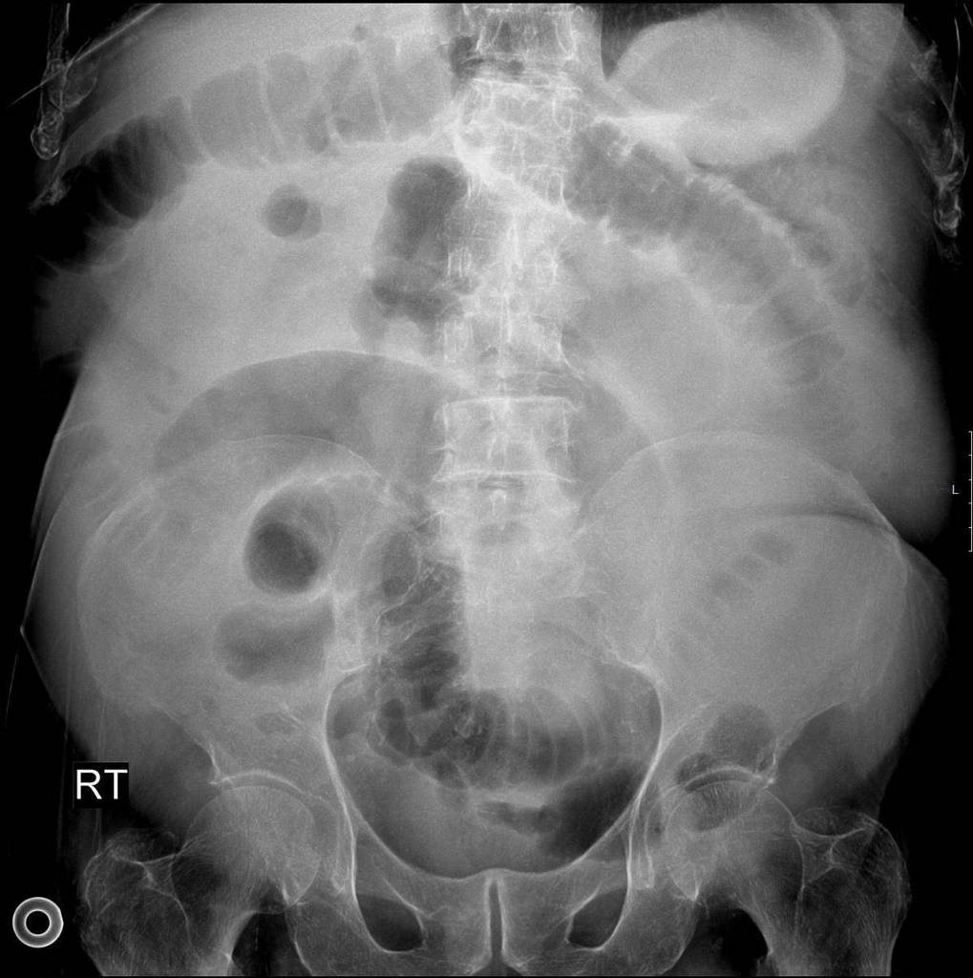

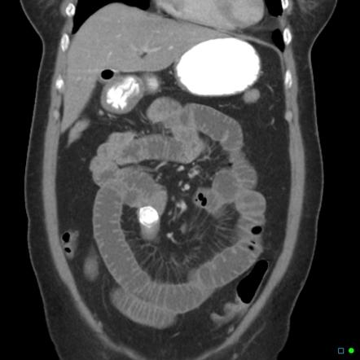

What is your differential diagnosis?
- Small bowel obstruction
- Gallstone ileus
- Mesenteric ischemia
- Intestinal perforation
- Malignancy

What would you like to do now?
- NGT decompression
- IV access
- Resuscitation.

Recognition of gallstone ileus on imaging
- OR for ex-lap
  - Inspect/palpate entire midgut
  - Longitudinal enterotomy, stone extraction and closure in H-M fashion

How do you mange cholecystoenteric fistula?
leave it alone in old, frail and sick people

Scenario 1: Same patient, however, you are unable to milk the stone out proximally.
Perform a segmental small bowel resection.
Scenario 2: Same patient successfully treated with enterotomy with stone retrieval and primary closure of the small bowel. In the coming days becomes increasingly tachycardic, febrile, and hypotensive.

What is you diagnosis? How would you manage
Enteric leak
- IVF resuscitation.
- Empiric abx.
- If stable CT
- Versus Immediate return to OR

Scenario3: Gallstones ileus identified in a 60-year-old farmer with history of HTN and HLD, otherwise physically active and relatively healthy.
What would you do with the gallbladder and cholecystoenteric fistula in this setting?

- Explores gallbladder and identifies whether there are residual stones
- If patient is stable and can undergo long procedure would be acceptable to perform cholecystectomy and closure of cholecystoenteric fistula at time of surgery, otherwise perform as staged procedure.
- At time of cholecystectomy, performs cholangiogram to ensure CBD exploration does not need to be performed.

Describe how to repair the duodenum?
Debride edges if needed, assess posterior wall and ampulla, primary repair transversely to avoid stricture. Protection of repair: buttress with omental fat/falciform, serosal flap. JP drain.

Room 3 Question 2
GIST.

Stem: A 70yoF presents to your office with complaints of 4 months of early satiety. He denies any nausea/emesis, constipation.. He denies hematechezia or hematemesis. Last colonoscopy 5 years ago, normal. He endorses a 10lb weight loss in the same amount of time

PMHx: hyperlipidemia, hypertension

PSHx: inguinal hernia repair 30 years ago

Meds: metoprolol, cholesterol med, baby aspirin

SocHx: social drinker; 20 pack year history smoker, quit 20 years ago

FH: Non-contributory

Vital Signs: BP 142/85 HR 75 99% on room air

PE: well-appearing male although thin. Abdomen soft, nontender with palpable left upper abdominal mass. No associated lymphadenopathy

How would you work up this patient?

CT abd/pelvis with IV/PO contrast – 7cm heterogenous mass associated with the gastric fundus without evidence of liver or peritoneal metastases or adenopathy

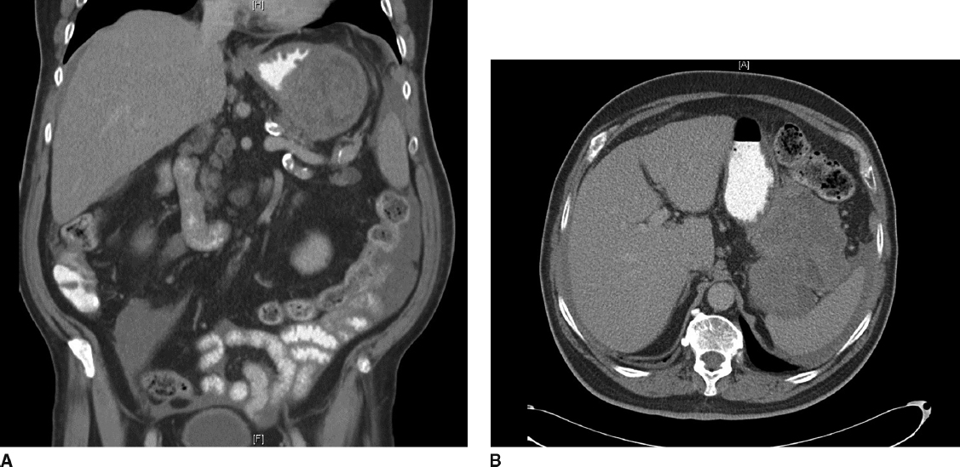

Diagnosis:

Gastrointestinal stromal tumor

What would you like to do next?

EGD

How would you perform that procedure?

Procedural sedation

Place in left lateral decubitus position

Insert scope into mouth under direct visualization

Pass the scope past the cricoarytenoid cartilage into the esophagus

Ensuring direct visualization, pass the scope through the esophagus with continuous insufflation in order to visualize the entire esophagus

Visualize the gastroesophageal junction and pass into the stomach

EGD demonstrates large submucosal mass without any ulceration.

If examinee asks for :
- biopsy: no pathologic abnormality
- EUS: large heterogenous mass contiguous with gastric wall without perigastric lymphadenopathy
- FNA: spindle cells, immunohistochemistry not performed. (FNA not necessary unless concerned for metastatic spread, unresectable or neoadjuvant therapy is planned)
- MRI or PET – not available

How would you treat this patient?

Resectable GIST. No neoadjuvant therapy is necessary

Describe operative approach:

Can perform laparoscopically or open.
- If laparoscopic need to describe position and port placement: lithotomy or supine position with 12mm port to the left of the umbilicus, 4 additional ports – right of umbilicus, right costal margin, left costal margin and liver retractor
- Open – supine position, upper midline celiotomy

Examine the abdomen for metastases

Resect the GIST with 1cm gross margin utilizing staple device, ensuring not to narrow the gastroesophageal junction.

Should use endoscopy or bougie to ensure against narrowing of stomach or GE junction. Should perform leak test

Ensure not to disrupt the pseudocapsule and cause spillage of tumor

Pathology returns 7cm gastrointestinal stromal tumor with mitotic rate >50/HPF

Any other recommendations for this patient’s care?

Imatanib for at least 3 years

H&P as well as CT scan every 6months-1 year for at least 10 years

Room 3 Question 3

Burn (Reviewed by Dr. Newell)
Stem: A 47 y/o male is brought to the ED by EMS after being evacuated from a bedroom fire, started while he was smoking in his bed.
Upon evaluation he is awake and conversive but appears confused.
He is noted to have 60% TBSA burns to his upper torso, sparing only his lower extremities. His nasal hair is singed and he has a productive cough with a hoarse voice.
HR- 115, RR- 30, BP – 95/50, Temp – 37C, SpO2-100%.

Additional Workup or Studies:
CMP, CBC, carboxyhemoglobin, lactate

What are you concerned about?!:
- Airway compromise with an upper airway inhalation injury
- Development of decreased pulmonary compliance with circumferential burns to the torso
- Carbon monoxide poisoning
- Hypothermia
- ARDS/multisystem organ failure
- Compartment syndrome in extremities or abdomen

What would you like to do now?
- Intubate – 100% FiO2
- Serial carboxyhemoglobin levels
- Establish adequate IV access and initiate fluid resuscitation using parkland formula:
2-4 ml/kg/%TBSA burn using LR. First ½ within 8 hours of burn.
Second ½ in the next 16 hours
- Place a foley to monitor resuscitation. Goal 30 – 50 cc/hr

Scenario: Patient has been transported to the ICU and is being mechanically ventilated. You get a call from respiratory therapy that his peak airway pressures have increased to 35. What are you concerned about?

- Abdominal compartment syndrome.
- Restrictive physiology due to thoracic eschars)

What would you do?
- check bladder pressure
- Perform escharotomy of thorax

Describe
- Escharotomy of the thorax
- Vertical incision bilaterally between mid-clavicular line and mid axillary line.
- Connected by transverse incision x 2
- Bronchoscopy to evaluate degree of inhalational injury for prognostication and treat potential mucus plugging
What is the ARDS/vent management?
- Low tidal volume (4-6 ml/kg)
- Peak pressures <30
- Permissive hypercapnia (ph >7.2)
- Increase PEEP
- Consider proning.

Scenario 4: 65 y/o male cement worker presents after cement has spilled through his shirt on his chest and he continued to work in the sun for the next 6 hours but noticed a terrible burning sensation over the area at the end of his shift. HR 90, BP 120/80, RR 15, Temp 37.2, what would you do?

- Call Poison control to obtain further recommendations and verify acid vs alkali
- Determine alkali burn – liquefactive necrosis.
- Begin burn resuscitation.
- Large volume lavage with water until pH <8, may require operative debridement.

